**PROJECT PROTOTYPE**

**FORM 1:**

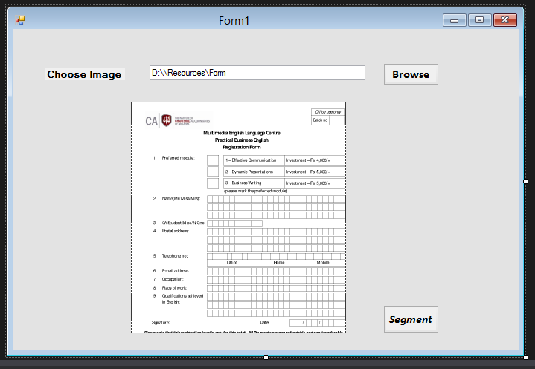

**FORM 2:**

